EventFlow: COS 214 Practical 3
Vimbai Chivunga u25136608
Chelsy Whata u25657764
Sudud Abughazaleh u25282728

Task 1:
  - Event Concept
Astral Fields Festival is a three-day outdoor music and arts festival held across a single large venue. The festival is organised into physically separate zones that each need to be opened, closed, reported on and sized in the same way, while individual operational units inside each zone (stages, gates, vendors, staff teams) must react differently to the same event-wide announcement. This mix of uniform part-whole structure and heterogeneous reaction to shared notices is exactly what EventFlow is built to coordinate.

The venue is represented as a single root event ("Astral Fields Festival") containing three top-level zones: the Plaza Zone (the main stage area), the River Zone (a secondary stage and transport hub) and the Camping Zone (overnight accommodation and support services). The Plaza Zone itself contains a nested Food Court sub-zone, giving the tree three levels of Composite nesting below the client/root boundary (root -> zone -> sub-zone -> unit), as well as units placed directly under a zone (root -> zone -> unit).

At least three kinds of grouping/area appear in the Composite tree:
- The root event (Astral Fields Festival) - the top of the tree, associated with EventControl but not owned by it.
- Top-level zones (Plaza Zone, River Zone, Camping Zone) - each an independently opened/closed/reported-on area with its own capacity threshold.
- A nested sub-zone (Food Court) - a Composite contained inside another Composite, proving the tree is genuinely recursive rather than exactly two fixed levels.

At least five (in fact eight) concrete kinds of event unit appear as leaves:
- Stage - hosts a performance; pauses on safety notices and resumes on instruction.
- Gate - admits attendees by ticket type; stops admitting on safety or closing notices.
- Vendor - sells food/drink; suspends service on safety or capacity-related notices.
- InfoDesk - guides visitors; deliberately stays open through safety notices.
- ShuttleStop - runs a transport route; reroutes rather than stopping on a weather notice.
- MedicalTeam - provides first aid; stays operational through every safety notice.
- SecurityPost - patrols a sector; can register with EventControl directly, outside the ownership tree, to show observation does not require containment.
- PowerStation - supplies backup power; enters a low-power mode on a weather notice (an original feature not required by the brief).
A central control room, EventControl, issues notices - opening, schedule changes, capacity warnings, weather alerts, pauses, resumptions and evacuation orders - that cascade down through the zone tree to whichever units are currently registered to receive them, and reorganisation (e.g. reassigning a vendor from one zone to another) can happen at runtime without breaking either the ownership tree or the notification registrations.
  - GoF Participant Mapping (Observer and Composite)
Several classes participate in more than one collaboration. Each role is listed on its own row and explained separately, as required.

Class | GoF Role(s) | Pattern | Collaboration this role applies to
EventComponent | Component | Composite | Common interface implemented by both EventUnit and EventGroup so a client can open/close/report/size any part of the event tree without knowing whether it holds a single unit or a whole subtree.
EventUnit | Leaf | Composite | Represents a single operational unit (Stage, Gate, Vendor, InfoDesk, ShuttleStop, MedicalTeam, SecurityPost, PowerStation) with no children of its own.
EventUnit | Concrete Observer | Observer | Reacts to a pushed Notice via update(), applying the shared open/close/pause state machine and, in each concrete subclass, an event-specific rule (e.g. Stage pauses, Vendor suspends service).
EventGroup | Composite | Composite | Represents a zone/area that holds and recursively operates on child EventComponents (open, close, reportStatus, getCapacity).
EventGroup | Concrete Observer | Observer | Receives a Notice pushed from its own parent (or from EventControl if it is the root) and records it as the group's last notice.
EventGroup | Concrete Subject | Observer | Having received a notice as an Observer, EventGroup immediately acts as a Subject and calls notify() to cascade that same notice to its own registered child observers - this is what makes multi-level cascading possible.
Subject | Subject | Observer | Abstract registration/notification interface: attach(), detach(), notify(), and the non-owning observer list.
Observer | Observer | Observer | Abstract reaction interface: update(Notice&).
EventControl | Concrete Subject | Observer | The top-level broadcaster. Client code calls broadcast(notice), which calls notify() to push the notice to every registered top-level observer (normally the root EventGroup, plus any monotask observers such as SecurityPost).
main() (Client) | Client (Composite) / Client (Observer) | Observer and Compositr | Builds the composite tree with add(), wires up observer registrations with attach(), and drives the scenario through EventControl.broadcast().

  - UML Class Diagram
The completed class diagram below shows the abstract base classes (EventComponent, Observer, Subject, Notice) with their operations, the inheritance relationships to concrete classes, the Composite ownership association (filled diamond, 0..* children, owned), the Observer registration association (open arrow, 0..* observers, explicitly non-owning), the non-owning root association from EventControl to EventGroup, and the eight concrete leaves and eight concrete notice types. Every abstract base declares a virtual destructor.
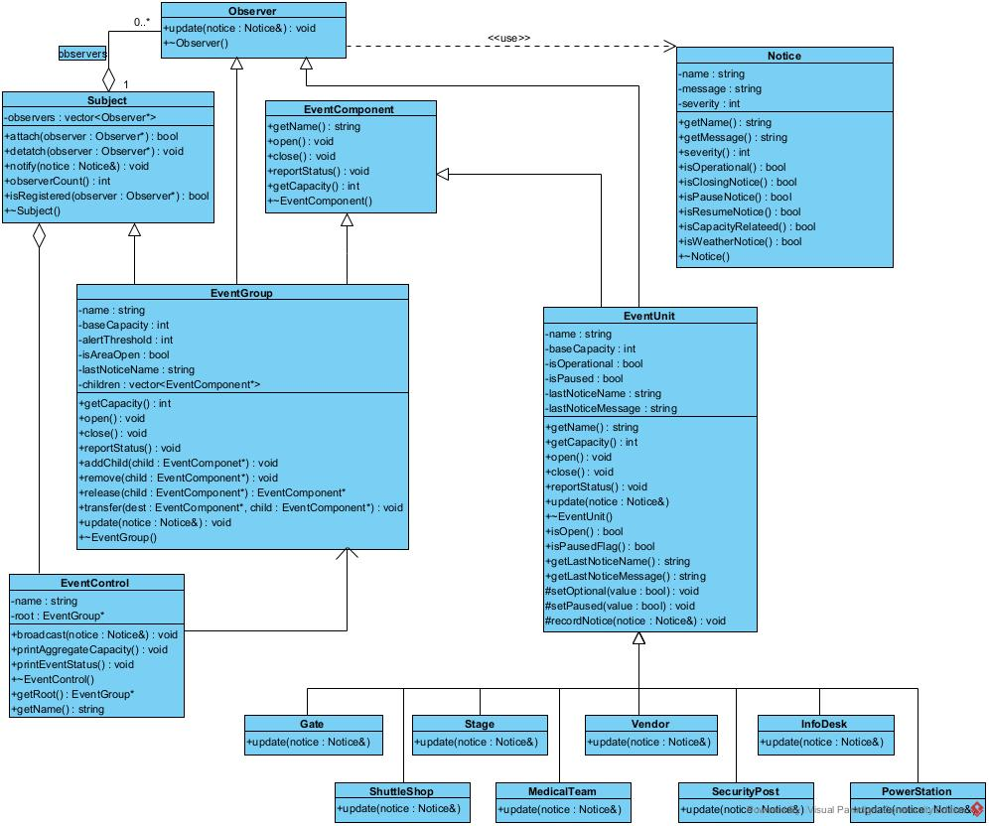

1.4 Design Rationale

(a) Why the Composite is a genuine part-whole tree
EventGroup does not merely group EventComponents for convenience of iteration - it recursively delegates the same operations (open, close, reportStatus, getCapacity) to every child, so a zone's aggregate capacity is always the sum of its own base capacity plus every descendant's capacity, computed on demand rather than cached and kept in sync by hand. Because EventGroup itself implements EventComponent, a group can contain other groups (Food Court inside Plaza Zone) as well as leaves, giving arbitrary depth rather than a fixed two-level structure. This satisfies the defining property of Composite: the client (main(), EventControl) manipulates a single unit and an entire subtree through the exact same interface and never needs to know which one it is holding.

(b) Why Observer is required rather than direct hard-coded calls
EventControl and the intermediate EventGroups do not know, at compile time, the concrete set of units that must react to a given notice - that set changes at runtime (SecurityPost is attached, detached and re-attached during the demonstration; Coffee Vendor is transferred between zones and carries its observer registration with it). A hard-coded sequence of calls in EventControl would have to name every concrete leaf type and would break every time a unit was added, removed or moved. Observer replaces that with a single loop over a registration list that is built and modified entirely at runtime, so EventControl and EventGroup depend only on the abstract Observer interface, never on Stage, Gate, Vendor, etc. by name.

(c) Who owns event components
EventGroup owns every EventComponent in its children vector. add() transfers ownership into a group; the group's destructor deletes every component still present in that vector when the group itself is destroyed, so deleting the root releases the entire owned subtree exactly once. Ownership can move between groups at runtime: release() removes a child from a group's children vector and returns it without deleting it, and transfer() combines release() on the source with add() on the destination so a component is owned by exactly one group at any moment and is never deleted twice. EventControl and the client (main()) hold only a non-owning EventGroup* to the root and never delete event components themselves except through the root's destructor.

(d) Who owns (or does not own) observer references
Subject stores observers as raw, explicitly non-owning pointers. This is necessary because an object registered as an observer is frequently owned elsewhere for a completely different reason - a Vendor, for example, is owned by its EventGroup (Composite ownership) while simultaneously being registered as an observer of that same group (Observer registration). If Subject deleted its observers, this would either double-delete objects also owned by a Composite parent, or would incorrectly take ownership of monotask observers such as SecurityPost that the client owns directly and outlives any particular registration. The two relationships are kept independent: attach()/detach() only ever change the registration list, never call delete, and object lifetime is managed entirely through the Composite ownership tree or by the client.

(e) Why EventGroup being both Subject and Observer is not a misuse of either pattern
EventGroup implements Observer so that it can receive a notice cascading down from its own parent, and implements Subject so that it can then notify its own children. These are two distinct collaborations with two distinct sets of correspondents: as an Observer, EventGroup's correspondent is whatever registered it (its parent group, or EventControl for the root); as a Subject, EventGroup's correspondents are its own registered children, which is a completely different set of objects for a different reason. update() in EventGroup demonstrates the separation directly: it first performs the Observer reaction (record the notice, check the capacity threshold), and only then calls notify() to perform the Subject role. Nothing here collapses the two patterns into one - a class simply sits at the boundary between two independent one-to-many relationships, which is exactly the situation the practical brief anticipates when it says a class may participate in more than one pattern collaboration for different reasons.

